**Assignment 3**

**Team Members**

|  |  |  |  |
| --- | --- | --- | --- |
| **Num** | **Full Name in ARABIC** | SEC | BN |
| 1 | عبدالرحمن محمد سالم حسن | 1 | 38 |
| 2 | احمد فوزى محمد إبراهيم | 1 | 8 |

**Table of contents:**

1. Part One 3

1.1 Gram-Schmidt Orthogonalization 3

1.2 Signal Space Representation 5

1.3 Signal Space Representation with adding AWGN 6

1.4 Noise Effect on Signal Space 9

2. Appendix A: Codes for Part One: 10

A.1 Code for Gram-Schmidt Orthogonalization 10

A.2 Code for Signal Space representation 11

A.3 Code for plotting the bases functions 11

A.4 Code for plotting the Signal space Representations 12

A.5 Code for effect of noise on the Signal space Representations 15

**List of Figures**

Figure 1 Φ1 VS time after using the GM_Bases function 3

Figure 2 Φ2 VS time after using the GM_Bases function 4

Figure 3 Signal Space representation of signals s1,s2 5

Figure 4 Signal Space representation of signals s1,s2 with E/σ¬2 =10dB 6

Figure 5 Signal Space representation of signals s1,s2 with E/σ¬2 =0dB 7

Figure 6 Signal Space representation of signals s1,s2 with E/σ¬2 =-5dB 8

# Part One

## 1.1 Gram-Schmidt Orthogonalization

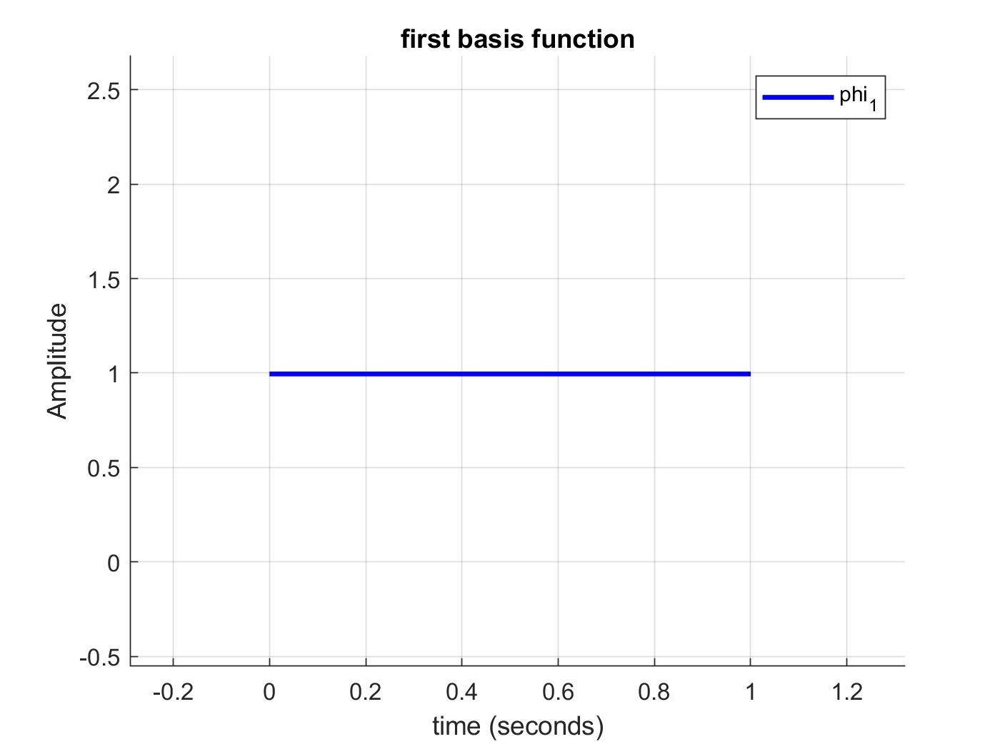Here we are getting the basis functions of the 2 signals s1,s2 where s1 or s2 can be formed using equations using only phi1 and phi2 and some factors and also the dot product between phi1 and phi2 is 0

Figure Φ1 VS time after using the GM_Bases function

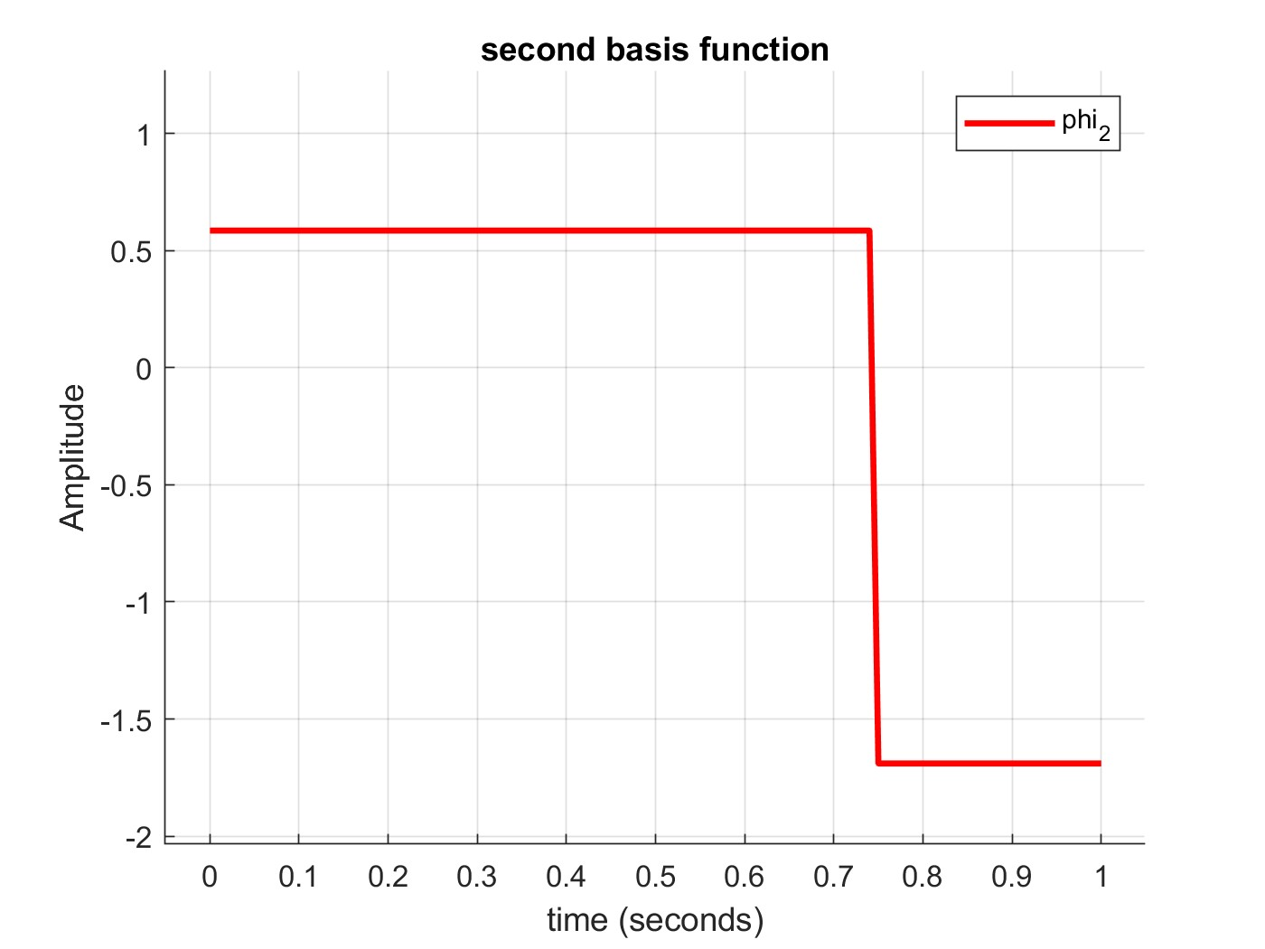

Figure Φ2 VS time after using the GM_Bases function

## 1.2 Signal Space Representation

Here we represent the signals using the base functions.

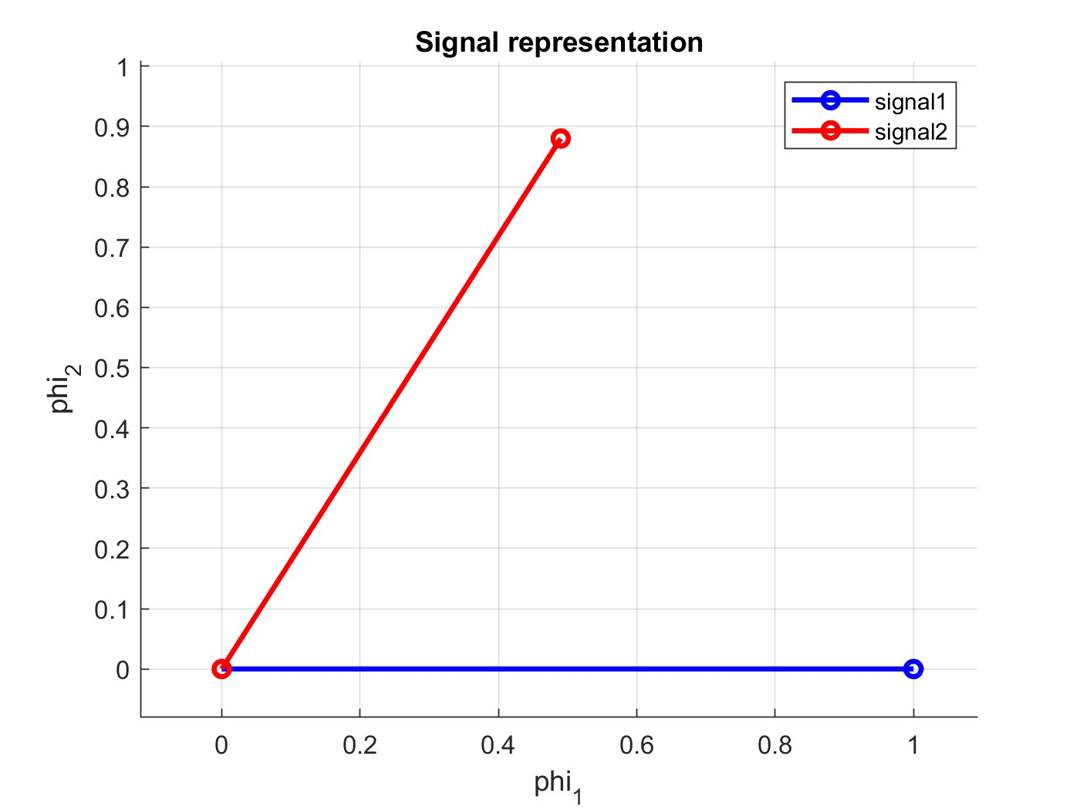

Figure Signal Space representation of signals s1,s2

## 1.3 Signal Space Representation with adding AWGN

-the expected real points will be solid and the received will be hollow

**Case 1**: $10 log(E/σ^{2}) = 10 dB$

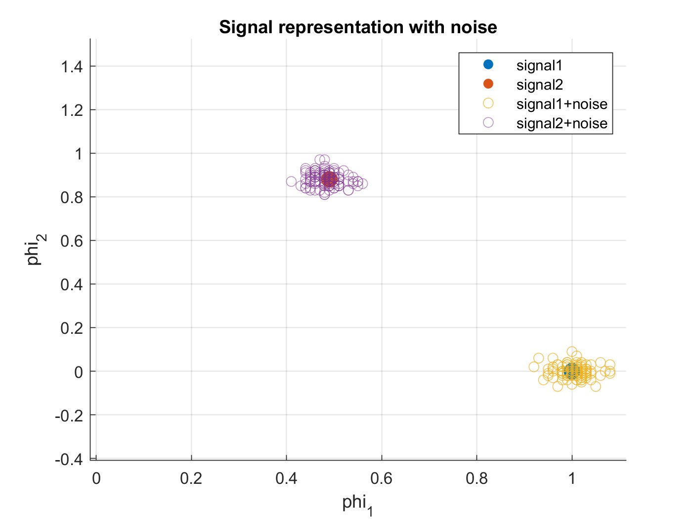

Figure Signal Space representation of signals s1,s2 with E/σ¬2 =10dB

**Case 2**: $10 log(E/σ^{2}) = 0 dB$

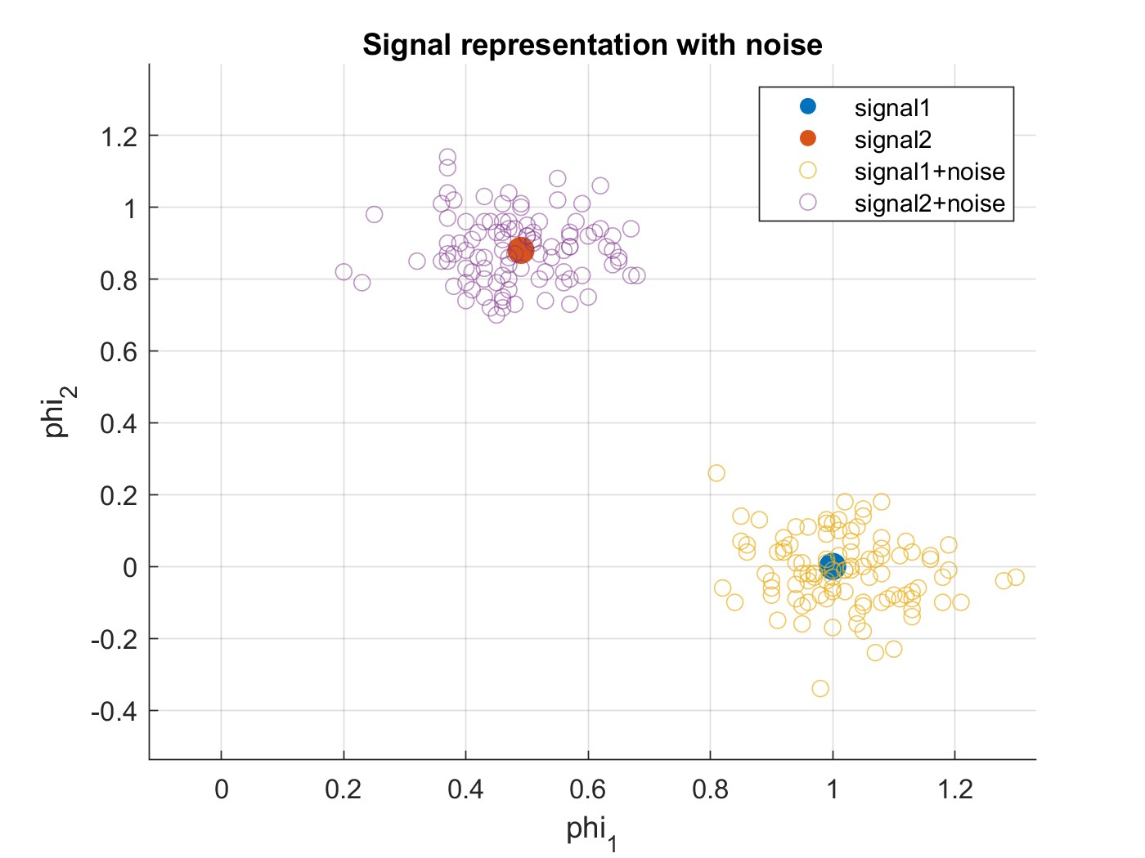

Figure Signal Space representation of signals s1,s2 with E/σ¬2 =0dB

**Case 3**: $10 log(E/σ^{2}) = -5 dB$

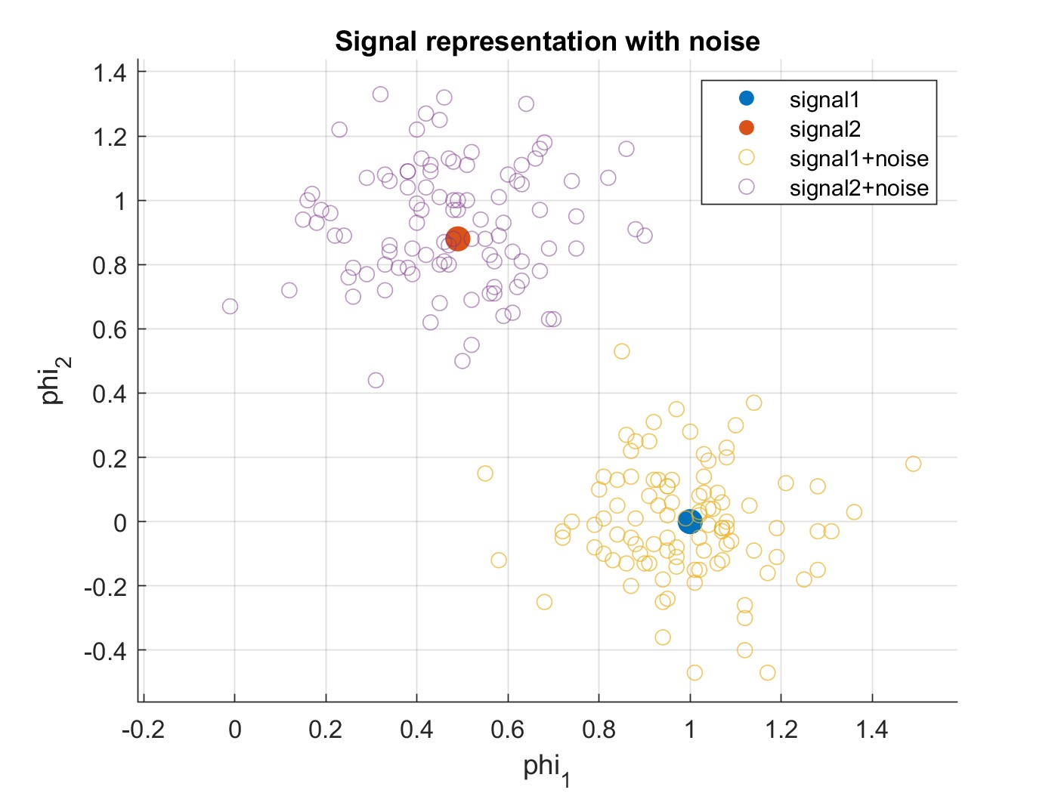

Figure Signal Space representation of signals s1,s2 with E/σ¬2 =-5dB

## 1.4 Noise Effect on Signal Space

With the increase of the variance of the noise, the resultant signal becomes more noisy so it becomes near to the decision boundary between the 2 signals and accordingly can be classified wrongly so we can notice that at snr=10db, the resultant signals are more compact near the ideal signal projection while at snr=-5, the resultant signals are more spread around the ideal space and near the decision boundary between the symbols.

# Appendix A: Codes for Part One:

## A.1 Code for Gram-Schmidt Orthogonalization

|  |
| --- |
| %-------------------------------------  % Requirment 1.1  %-------------------------------------  % this function is used to find the basis of 2 signals  function [phi1,phi2] = GM_Bases(s1,s2)    % get the energy of the 1st signal  E1 = sum(abs(s1).^2) / 100;    % calculate phi1  phi1 = s1 ./ sqrt(E1);  % calculate S21  s21 = sum(phi1 .* s2) / 100;  % get intermediate variable called g2  g2 = s2 - s21 .* phi1;  % get the energy of g2  Eg2 = sum(abs(g2).^2) / 100;  % calculate phi2  phi2 = g2 ./ sqrt(Eg2);  % if the 2 basis are the same then make the 2nd basis 0  if phi2(:) == phi1(:)  phi2(:) = 0;  end  end |

## A.2 Code for Signal Space representation

|  |
| --- |
| %-------------------------------------  % Requirment 1.2  %-------------------------------------  % this function is used to get the signal space of s in terms of phi1 and  % phi2  function [v1,v2] = signal_space(s, phi1,phi2)  % correlate the signal with 1st basis  v1 = sum(phi1 .* s) / 100;    % correlate the signal with 2nd basis  v2 = sum(phi2 .* s) / 100;  % round the values to the nearest 2 digits  v1 = round(v1, 2);  v2 = round(v2, 2);    end |

## A.3 Code for plotting the bases functions

|  |
| --- |
| % construct our signals  T = 0:0.01:1;  s1 = ones(1, 101);  s2 = ones(1, 101);  s2(76:end) = -1;  % get the bases of these 2 signals and plot them  [phi1, phi2] = GM_Bases(s1, s2);  temp = sum(dot(phi2, phi1));  % plot the first basis function  figure;  hold on  title("first basis function");  xlabel('time (seconds)');  ylabel('Amplitude');  plot(T, phi1, 'DisplayName', 'phi_1', 'LineWidth', 2, 'Color', 'blue');  grid on  legend;  hold off  % plot the second basis function  figure;  hold on  title("second basis function");  xlabel('time (seconds)');  ylabel('Amplitude');  plot(T, phi2, 'DisplayName', 'phi_2', 'LineWidth', 2, 'Color', 'red');  grid on  legend;  hold off |

## A.4 Code for plotting the Signal space Representations

|  |
| --- |
| % get the signal projection in the domain of phi1 and phi2  [S1_Projection_Phi1, S1_Projection_Phi2]= signal_space(s1, phi1, phi2);  [S2_Projection_Phi1, S2_Projection_Phi2]= signal_space(s2, phi1, phi2);  % plot the projections of the signals in the axis of phi1 and phi2  figure;  hold on  title("Signal representation");  xlabel('phi_1');  ylabel('phi_2');  plot([0, S1_Projection_Phi1], [0, S1_Projection_Phi2], '-o', 'DisplayName', 'signal1', 'LineWidth', 2, 'Color', 'blue');  plot([0, S2_Projection_Phi1], [0, S2_Projection_Phi2], '-o', 'DisplayName', 'signal2', 'LineWidth', 2, 'Color', 'red');  grid on  legend;  hold off |

## A.5 Code for effect of noise on the Signal space Representations

|  |
| --- |
| % scatter when snr = -5 db  plotNoisyProjectionSignal(phi1, phi2, s1, s2, S1_Projection_Phi1, S1_Projection_Phi2, S2_Projection_Phi1, S2_Projection_Phi2, 101, -5);  % scatter when snr = 0 db  plotNoisyProjectionSignal(phi1, phi2, s1, s2, S1_Projection_Phi1, S1_Projection_Phi2, S2_Projection_Phi1, S2_Projection_Phi2, 101, 0);  % scatter when snr = 10 db  plotNoisyProjectionSignal(phi1, phi2, s1, s2, S1_Projection_Phi1, S1_Projection_Phi2, S2_Projection_Phi1, S2_Projection_Phi2, 101, 10);  % this is a utility function to plot the actual signal projection and noisy  % signal projection  function [] = plotNoisyProjectionSignal(phi1, phi2, s1, s2, S1_Projection_Phi1, S1_Projection_Phi2, S2_Projection_Phi1, S2_Projection_Phi2, lenOfSample, snr)  % 2 variables will hold the projection of signal in the domain of phi1,  % phi2  Symbol1_NoiseSamples_XVal = zeros(1, lenOfSample);  Symbol1_NoiseSamples_YVal = zeros(1, lenOfSample);  Symbol2_NoiseSamples_XVal = zeros(1, lenOfSample);  Symbol2_NoiseSamples_YVal = zeros(1, lenOfSample);  % generate 100 sample with added noise where snr = -5db and plot it  for i = 1:lenOfSample    % generate 2 signals with noise  symbol1 = addNoise(s1, snr);  symbol2 = addNoise(s2, snr);  % get the projections of these signals in the basis domain  [symbol1_projectionPhi1, symbol1_projectionPhi2] = signal_space(symbol1, phi1, phi2);  [symbol2_projectionPhi1, symbol2_projectionPhi2] = signal_space(symbol2, phi1, phi2);    % add the point to the array  Symbol1_NoiseSamples_XVal(i) = symbol1_projectionPhi1;  Symbol1_NoiseSamples_YVal(i) = symbol1_projectionPhi2;  Symbol2_NoiseSamples_XVal(i) = symbol2_projectionPhi1;  Symbol2_NoiseSamples_YVal(i) = symbol2_projectionPhi2;    end  % plot the projections of the signals in the axis of phi1 and phi2  figure;  hold on  title("Signal representation with noise");  xlabel('phi_1');  ylabel('phi_2');  scatter(S1_Projection_Phi1, S1_Projection_Phi2, 100, 'filled', 'DisplayName', 'signal1');  scatter(S2_Projection_Phi1, S2_Projection_Phi2, 100, 'filled', 'DisplayName', 'signal2');  scatter(Symbol1_NoiseSamples_XVal, Symbol1_NoiseSamples_YVal, 'DisplayName', 'signal1+noise', 'MarkerEdgeAlpha', 0.7);  scatter(Symbol2_NoiseSamples_XVal, Symbol2_NoiseSamples_YVal, 'DisplayName', 'signal2+noise', 'MarkerEdgeAlpha', 0.5);  grid on  legend;  hold off  end  %-------------------------------------  % Requirment 1.3  %-------------------------------------  % this function is used to generate gaussian noise and add it to the signal  function [r_t] = addNoise(signal, snr)    % generate the AWGN noise given the snr (since awgn function is only  % available on communication toolbox and I don't have on my matlab  % student version so I implemented awgn noise function)  r_t = awgn(signal, snr);  end  % this is the implemented awgn function and I implemented it as awgn  % function is only available on communcation toolbox that I don't have it  % on my matlab student licenece, the implementation of this function is  % taken from this link:  % https://www.gaussianwaves.com/gaussianwaves/wp-content/uploads/2015/06/How_to_generate_AWGN_noise.pdf  function [resultSignal] = awgn(signal, snr_db)    % get the length of the signal  L = length(signal);  % convert the SNR from log scale to linear scale  snr = 10 ^ (snr_db / 10);  % calculate the energy of the symbol  E = sum(abs(signal) .^ 2) / L;  % get the N0 of the symbol  N0 = E / snr;  % get the the actual noise  noise = sqrt(N0) * randn(1, L);    % return the result  resultSignal = signal + noise;  end |

## A.6 whole code in one file

|  |
| --- |
| %-------------------------------------  % Requirment 1.4  %-------------------------------------  % construct our signals  T = 0:0.01:1;  s1 = ones(1, 101);  s2 = ones(1, 101);  s2(76:end) = -1;  % get the bases of these 2 signals and plot them  [phi1, phi2] = GM_Bases(s1, s2);  temp = sum(dot(phi2, phi1));  % plot the first basis function  figure;  hold on  title("first basis function");  xlabel('time (seconds)');  ylabel('Amplitude');  plot(T, phi1, 'DisplayName', 'phi_1', 'LineWidth', 2, 'Color', 'blue');  grid on  legend;  hold off  % plot the second basis function  figure;  hold on  title("second basis function");  xlabel('time (seconds)');  ylabel('Amplitude');  plot(T, phi2, 'DisplayName', 'phi_2', 'LineWidth', 2, 'Color', 'red');  grid on  legend;  hold off  % get the signal projection in the domain of phi1 and phi2  [S1_Projection_Phi1, S1_Projection_Phi2]= signal_space(s1, phi1, phi2);  [S2_Projection_Phi1, S2_Projection_Phi2]= signal_space(s2, phi1, phi2);  % plot the projections of the signals in the axis of phi1 and phi2  figure;  hold on  title("Signal representation");  xlabel('phi_1');  ylabel('phi_2');  plot([0, S1_Projection_Phi1], [0, S1_Projection_Phi2], '-o', 'DisplayName', 'signal1', 'LineWidth', 2, 'Color', 'blue');  plot([0, S2_Projection_Phi1], [0, S2_Projection_Phi2], '-o', 'DisplayName', 'signal2', 'LineWidth', 2, 'Color', 'red');  grid on  legend;  hold off  % scatter when snr = -5 db  plotNoisyProjectionSignal(phi1, phi2, s1, s2, S1_Projection_Phi1, S1_Projection_Phi2, S2_Projection_Phi1, S2_Projection_Phi2, 101, -5);  % scatter when snr = 0 db  plotNoisyProjectionSignal(phi1, phi2, s1, s2, S1_Projection_Phi1, S1_Projection_Phi2, S2_Projection_Phi1, S2_Projection_Phi2, 101, 0);  % scatter when snr = 10 db  plotNoisyProjectionSignal(phi1, phi2, s1, s2, S1_Projection_Phi1, S1_Projection_Phi2, S2_Projection_Phi1, S2_Projection_Phi2, 101, 10);  % this is a utility function to plot the actual signal projection and noisy  % signal projection  function [] = plotNoisyProjectionSignal(phi1, phi2, s1, s2, S1_Projection_Phi1, S1_Projection_Phi2, S2_Projection_Phi1, S2_Projection_Phi2, lenOfSample, snr)  % 2 variables will hold the projection of signal in the domain of phi1,  % phi2  Symbol1_NoiseSamples_XVal = zeros(1, lenOfSample);  Symbol1_NoiseSamples_YVal = zeros(1, lenOfSample);  Symbol2_NoiseSamples_XVal = zeros(1, lenOfSample);  Symbol2_NoiseSamples_YVal = zeros(1, lenOfSample);  % generate 100 sample with added noise where snr = -5db and plot it  for i = 1:lenOfSample    % generate 2 signals with noise  symbol1 = addNoise(s1, snr);  symbol2 = addNoise(s2, snr);  % get the projections of these signals in the basis domain  [symbol1_projectionPhi1, symbol1_projectionPhi2] = signal_space(symbol1, phi1, phi2);  [symbol2_projectionPhi1, symbol2_projectionPhi2] = signal_space(symbol2, phi1, phi2);    % add the point to the array  Symbol1_NoiseSamples_XVal(i) = symbol1_projectionPhi1;  Symbol1_NoiseSamples_YVal(i) = symbol1_projectionPhi2;  Symbol2_NoiseSamples_XVal(i) = symbol2_projectionPhi1;  Symbol2_NoiseSamples_YVal(i) = symbol2_projectionPhi2;    end  % plot the projections of the signals in the axis of phi1 and phi2  figure;  hold on  title("Signal representation with noise");  xlabel('phi_1');  ylabel('phi_2');  scatter(S1_Projection_Phi1, S1_Projection_Phi2, 100, 'filled', 'DisplayName', 'signal1');  scatter(S2_Projection_Phi1, S2_Projection_Phi2, 100, 'filled', 'DisplayName', 'signal2');  scatter(Symbol1_NoiseSamples_XVal, Symbol1_NoiseSamples_YVal, 'DisplayName', 'signal1+noise', 'MarkerEdgeAlpha', 0.7);  scatter(Symbol2_NoiseSamples_XVal, Symbol2_NoiseSamples_YVal, 'DisplayName', 'signal2+noise', 'MarkerEdgeAlpha', 0.5);  grid on  legend;  hold off  end  %-------------------------------------  % Requirment 1.3  %-------------------------------------  % this function is used to generate gaussian noise and add it to the signal  function [r_t] = addNoise(signal, snr)    % generate the AWGN noise given the snr (since awgn function is only  % available on communication toolbox and I don't have on my matlab  % student version so I implemented awgn noise function)  r_t = awgn(signal, snr);  end  % this is the implemented awgn function and I implemented it as awgn  % function is only available on communcation toolbox that I don't have it  % on my matlab student licenece, the implementation of this function is  % taken from this link:  % https://www.gaussianwaves.com/gaussianwaves/wp-content/uploads/2015/06/How_to_generate_AWGN_noise.pdf  function [resultSignal] = awgn(signal, snr_db)    % get the length of the signal  L = length(signal);  % convert the SNR from log scale to linear scale  snr = 10 ^ (snr_db / 10);  % calculate the energy of the symbol  E = sum(abs(signal) .^ 2) / L;  % get the N0 of the symbol  N0 = E / snr;  % get the the actual noise  noise = sqrt(N0) * randn(1, L);    % return the result  resultSignal = signal + noise;  end  %-------------------------------------  % Requirment 1.1  %-------------------------------------  % this function is used to find the basis of 2 signals  function [phi1,phi2] = GM_Bases(s1,s2)    % get the energy of the 1st signal  E1 = sum(abs(s1).^2) / 100;    % calculate phi1  phi1 = s1 ./ sqrt(E1);  % calculate S21  s21 = sum(phi1 .* s2) / 100;  % get intermediate variable called g2  g2 = s2 - s21 .* phi1;  % get the energy of g2  Eg2 = sum(abs(g2).^2) / 100;  % calculate phi2  phi2 = g2 ./ sqrt(Eg2);  % if the 2 basis are the same then make the 2nd basis 0  if phi2(:) == phi1(:)  phi2(:) = 0;  end  end  %-------------------------------------  % Requirment 1.2  %-------------------------------------  % this function is used to get the signal space of s in terms of phi1 and  % phi2  function [v1,v2] = signal_space(s, phi1,phi2)  % correlate the signal with 1st basis  v1 = sum(phi1 .* s) / 100;    % correlate the signal with 2nd basis  v2 = sum(phi2 .* s) / 100;  % round the values to the nearest 2 digits  v1 = round(v1, 2);  v2 = round(v2, 2);    end |